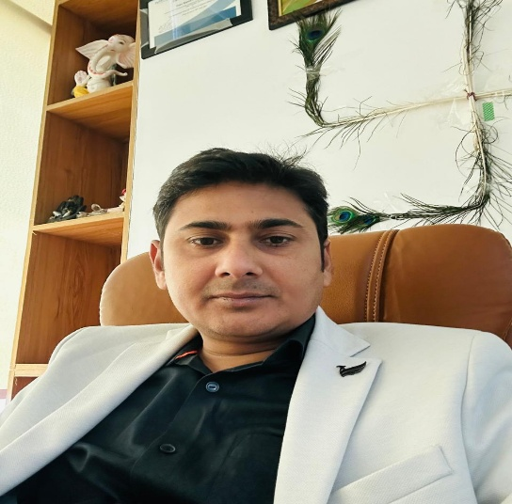
Mr. Manohar Kumar: Director & Co-founder
Mr. Manohar Kumar is a highly experienced professional with over 15 years of expertise in the solar energy industry. He specializes in solar power solutions, renewable energy projects, project management, system planning, and sustainable energy development. With a strong commitment to innovation, quality, and customer satisfaction, he has successfully led and executed numerous residential, commercial, and industrial solar projects. His in-depth industry knowledge, strategic vision, and dedication to promoting clean energy continue to drive the company's growth and mission of delivering reliable and efficient solar solutions.
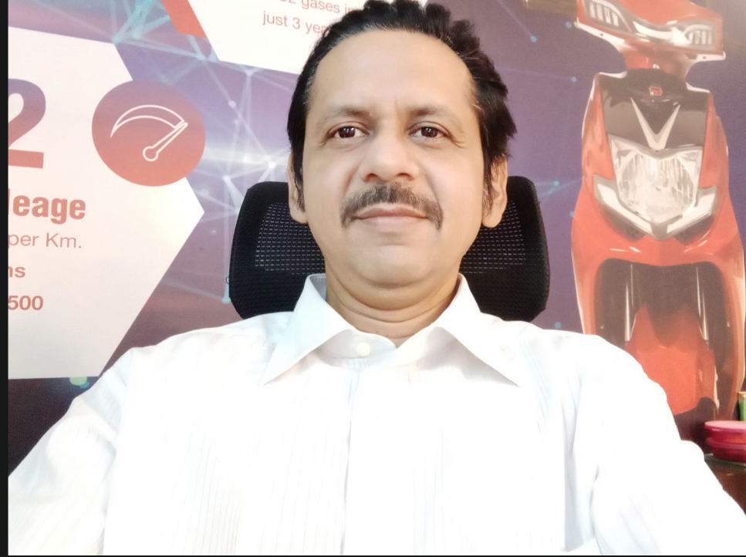
Mr. Neeraj Chauhan: Chief Executive Officer (CEO)
Mr. Neeraj Chauhan is a visionary leader with over 25 years of experience in business leadership, strategic planning, and organizational growth. He has a proven track record of driving innovation, building high-performing teams, and delivering sustainable business success. His extensive industry expertise, customer-centric approach, and commitment to excellence continue to lead the organization toward long-term growth and operational excellence.
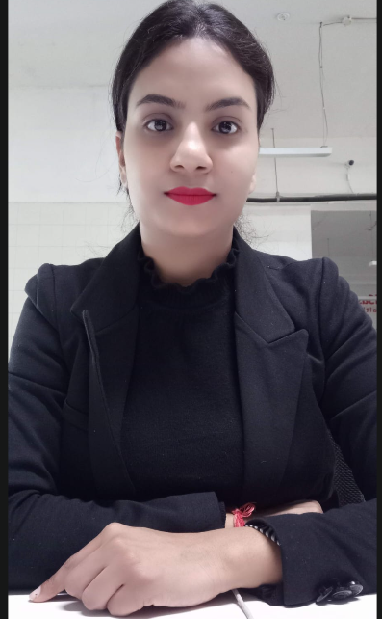
Muskan Sharma: Project Manager
Muskan Sharma is a dedicated professional with over 5 years of experience in project management. She specializes in project planning, team coordination, client communication, and timely project execution. Her strong organizational skills and commitment to quality ensure the successful delivery of projects while maintaining high standards of efficiency and customer satisfaction
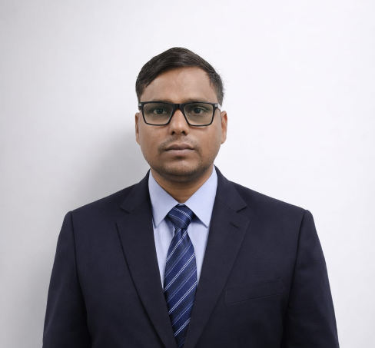
Rangesh Kumar: IT Operations Manager
Rangesh Kumar is an experienced IT professional with over 8.5 years of expertise in IT Operations. He specializes in IT infrastructure management, system administration, network operations, technical support, and process optimization. His proactive approach, technical expertise, and commitment to operational excellence help ensure reliable, secure, and efficient IT services while supporting the organization's business objectives.
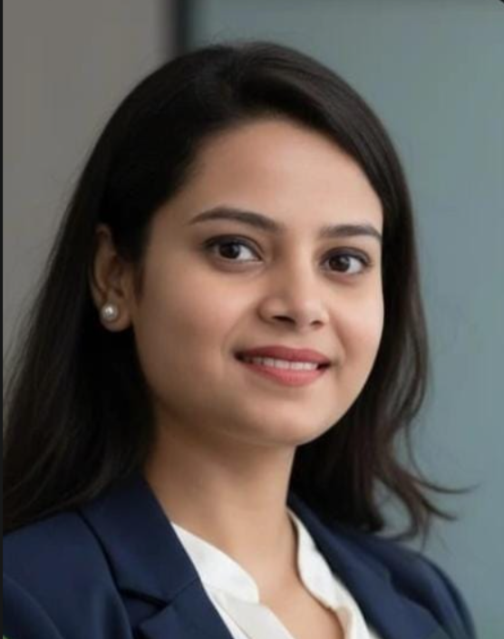
Mrs. Sapna Pandey: HR Operations
Mrs. Sapna Pandey is an HR professional with over 5 years of experience in HR Operations. She specializes in recruitment, employee engagement, payroll coordination, HR administration, and policy implementation. Her strong organizational skills and people-centric approach help create a productive work environment while ensuring smooth and efficient HR operations across the organization.

